**Validations In Resource Details**

Adding Resource Details in DSS Includes Two Process

1. If the resource is not reporting to you means then you have to **click** **cross domain resource request button.**
2. If the resource is reporting to you means you can add the resource directly **without clicking** **cross domain resource request button** . If you are adding consultant means you can add the resource directly.

**Cross Domain Resource Request**

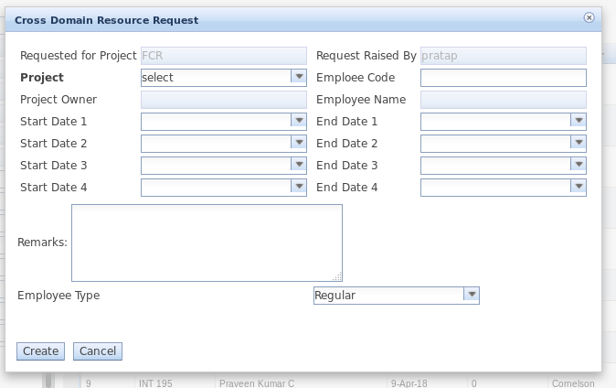

**Validations A Involved In Cross Domain Resource Request**

1. Select the start date and end date for same month.
2. Always end date should be greater than or equal to start date.
3. Duplicate dates are not allowed.
4. If you want to add multiple start date and end date means then you have to select respective start date and end date else no need to select start date2,start date3,start date4 and end date2,end date 3,end date 4.
5. If you are selecting only start date without selecting end date then you will get the **Only Start date is mentioned** alert message.
6. If you are selecting only end date without selecting start date you will get **Only end date is mentioned** alert message.
7. Overlapping dates are not allowed for particular resource.

Example:- If u enter the start date1 and end date 1 from 1st jan 2019 to 31st jan 2019 and then if u select start date 2 and end date 2 from 15th jan 2019 to 23th jan 2019 .In this case you will get overlapping dates are not allowed pop up message.

**6.** Fill the mandatory fields.

* Select the project.
* Employee name should not be null and empty space
* Enter valid Employee code and employee code should not be null and empty space.
* Select employee Type either Regular or Incentive.
* Select start date1 and end date1.
* Select the project from upper grid.

**Adding Resource Details**

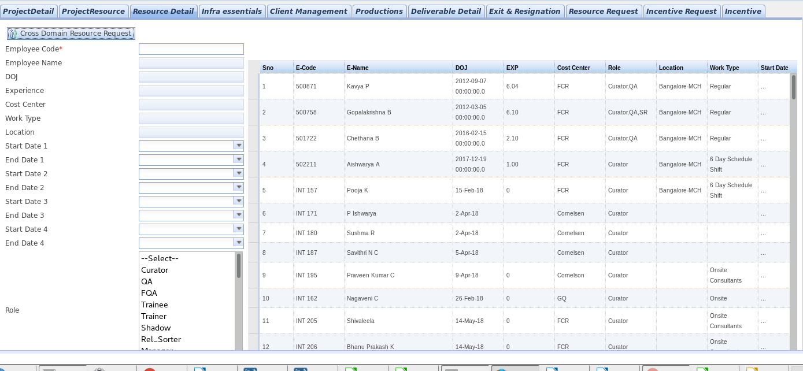

**Validations Involved In Adding Resource**

1. If you are entered incorrect employee code. Then you will get th**e Employee code not Present. Kindly contact HR department** alert message.
2. If you are entered employee code is not reporting to you means you will get **You are not a valid user for adding resource** alert message.
3. If the resource is already having parent project then mandatorily you have to select start date and end date else you will get the **Please mention the Start and End Dates** alert message.
4. If you are selecting only start date without selecting end date then you will get **Only Start date is mentioned** alert message.
5. If you are selecting only end date without entering start date you will get **Only end date is mentioned** alert message.
6. Select the start date and end date for same month.
7. Duplicate date are not allowed.
8. Overlapping dates are not allowed.
9. Always end date should be greater than or equal to start
10. If you want to add multiple start date and end date means then you have to select respective start date and end date else no need to select start date2,start date3,start date4 and end date2,end date 3,end date 4.
11. After entered employee code then check if the employee name and id are populated. If not populated, it would be because of HRMS Connectivity Issue. Add the resource after some time.
12. Fill the mandatory fields.

* Select the project from upper grid.
* Select employee Type either Regular or Incentive.
* Enter employee code and it should not be empty.
* Select Role it should not be empty.
* Employee name should not be empty.